**Virtual Jam ‘Scratch 1.4’: Lighting the Virtual LED**

Here is a simple Scratch 1.4 worksheet on how to create a “Virtual Light up LED” with the necessary big red button. You will need to download the template Scratch file from here [Link](https://github.com/ncscomputing/VirtualJam1/raw/master/led%20Template.sb).

The idea is the code will allow you to connect the wires, led and resister as below and you can virtually create your own lights show.

**Extension: ADD MORE COLOURED LEDS.**

**In action**

|  |
| --- |
|  |
|  |

**Resister**

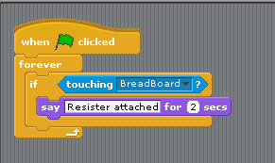

**#RJAM**

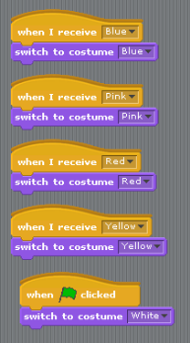

**LED**

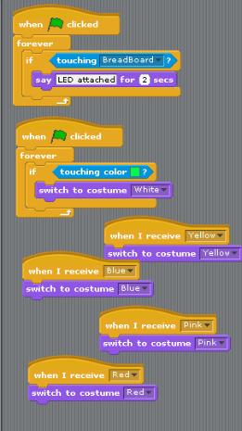

**Button**

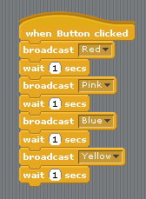

**Wires**

